STATISTICS ASSIGNMENT-

Que 1) Plot a histogram,
10, 13, 18, 22, 27, 32, 38, 40, 45, 51, 56, 57, 88, 90, 92, 94, 99

Solution- Considering Bin = 5
Bin Size= 20

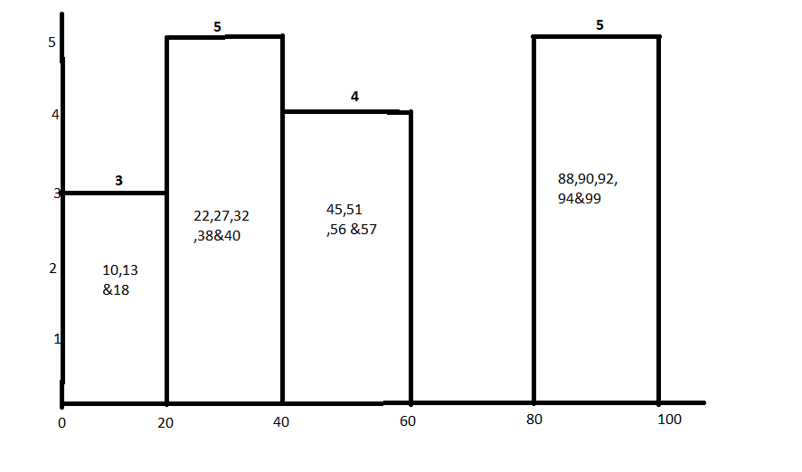

Que 2) In a quant test of the CAT Exam, the population standard deviation is known to be 100. A sample of 25 tests taken has a mean of 520. Construct an 80% CI about the mean.

Solution= The Confidence interval lies between 494.2- 545.8

PFB the screenshot for the solution.
Solution- 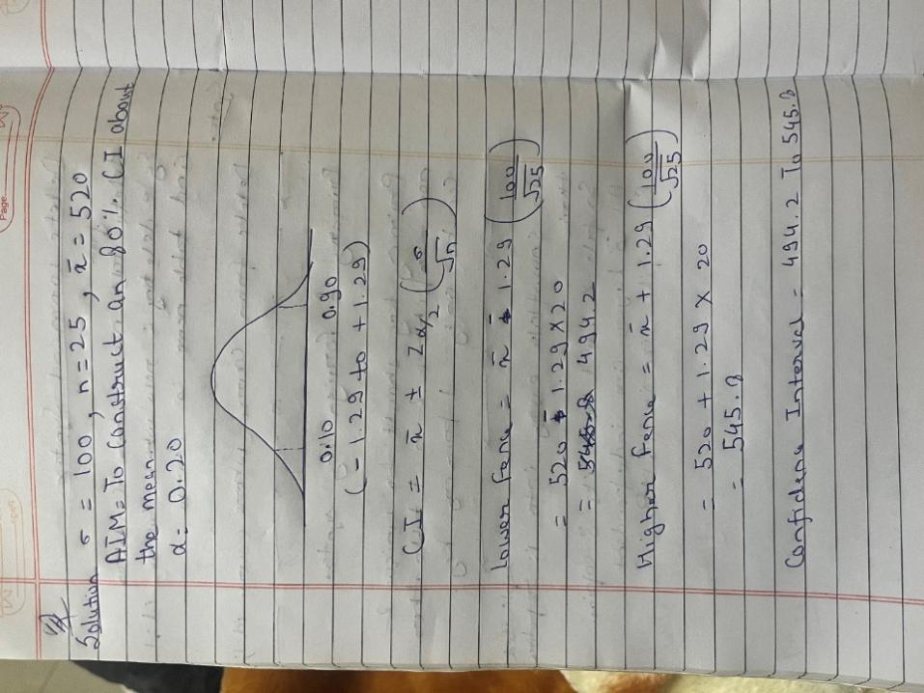

Que 3) A car believes that the percentage of citizens in city ABC that owns a vehicle is 60% or less. A sales manager disagrees with this. He conducted a hypothesis testing surveying 250 residents & found that 170 residents responded yes to owning a vehicle.
- State the null & alternate hypothesis.
- At a 10% significance level, is there enough evidence to support the idea that vehicle owner in ABC city is 60% or less.

Solution- P_{o}= .60
n=250
P(cap)= 170/250= 0.68
H₀=Po= 0.60
H₁= P₁ Not equal to 0.60
Z_{P}= 2.581
Decision Boundary with 10% significance level is from -1.65 to +1.65
As Z_{P}= 2.581 is outside the decision boundary hence we reject null hypothesis and accept alternate hypothesis.
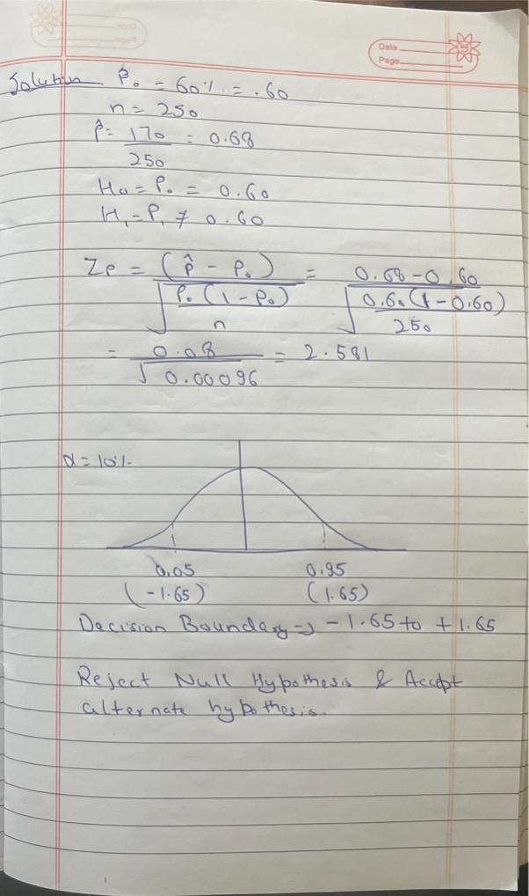

Que 4) What is the value of the 99 percentile?
2,2,3,4,5,5,5,6,7,8,8,8,8,8,9,9,10,11,11,12

Solution- n = 20
99% of the data = (99/100) *(n+1)
= (99/100)* 21
=20.79
99 percentile of the data is the variable present at 20.79 and in this case it would be data variable 12 which is present at location 20 closest to 20.79
So, 99 percentile is 12

Que 5) In left & right-skewed data, what is the relationship between mean, median & mode?
Draw the graph to represent the same.

Solution-
Right Skewed Data- Mean> Median> Mode

Left Skewed data- Mode> Median> Mean

